Worksheet 4

Student Name:Aryan Tomar UID:25MCI10167
Branch:MCA (AI&ML) Section/Group:1/A
Semester:2nd Date of Performance:04/02/2026
Subject Name:- DBMS LAB Subject Code: 25CAP-652

1. Aim of the Session

To understand and implement iterative control structures in PostgreSQL conceptually, including FOR loops, WHILE loops, and basic LOOP constructs, for repeated execution of database logic.

2. Software Requirements
- PostgreSQL (Database Server)
- pgAdmin
- Windows Operating System

3. Objective of the Session
- To understand why iteration is required in database programming
- To learn the purpose and behavior of FOR, WHILE, and LOOP constructs
- To understand how repeated data processing is handled in databases
- To relate loop concepts to real-world batch processing scenarios
- To strengthen conceptual knowledge of procedural SQL used in enterprise systems

4. Practical / Experiment Steps

Prerequisite Understanding

• Students should first understand that iterative control structures are executed inside PL/pgSQL blocks, not in normal SQL queries

• Students should create a table that stores multiple records so that loop execution over rows can be demonstrated

• The table should contain:
- A unique identifier
- A descriptive attribute (such as name or category)
- A numeric value to be processed repeatedly

5. Procedure of the Practical

(i) Start the system and log in to the computer.

(ii) Open PostgreSQL software.

iii) Create and select the database.

Create database Practical4;

(iv) Create table using DDL command.

CREATE TABLE employee (

emp_id SERIAL PRIMARY KEY,

emp_name VARCHAR(50),

salary NUMERIC(10,2)

);

(v) Insert records into the table.

INSERT INTO employee (emp_name, salary) VALUES

('Rahul', 40000),

('Ankit', 52000),

('Priya', 60000),

('Neha', 35000),

('Aman', 70000);

(vi) Display all records.

select*from schema_audit;

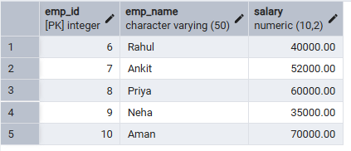

Step 1: FOR Loop – Simple Iteration

DO $$

BEGIN

FOR i IN 1..5 LOOP

RAISE NOTICE 'Iteration number: %', i;

END LOOP;

END $$;

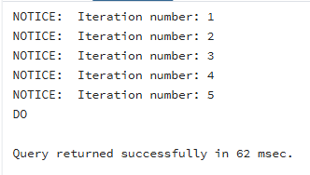

Step 2: FOR Loop with Query (Row-by-Row Processing)
DO $$
DECLARE
emp RECORD;
BEGIN
FOR emp IN SELECT emp_id, emp_name FROM employee LOOP
RAISE NOTICE 'Employee ID: %, Name: %', emp.emp_id, emp.emp_name;
END LOOP;
END $$;

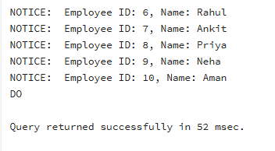

Step 3: WHILE Loop – Conditional Iteration
DO $$
DECLARE
counter INT := 1;
BEGIN
WHILE counter <= 5 LOOP
RAISE NOTICE 'Counter: %', counter;
counter := counter + 1;
END LOOP;
END $$;

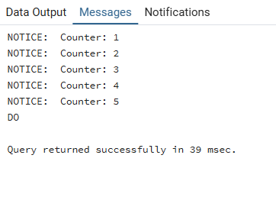

Step 4: LOOP with EXIT WHEN
DO $$
DECLARE
x INT := 1;
BEGIN
LOOP
RAISE NOTICE 'Value: %', x;
x := x + 1;
EXIT WHEN x > 5;
END LOOP;
END $$;

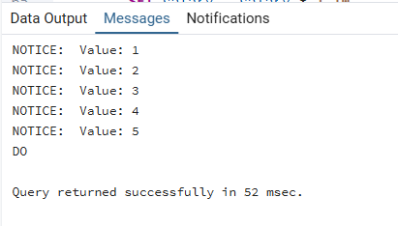

Step 5: Salary Increment Using FOR Loop
DO $$
DECLARE
emp RECORD;
BEGIN
FOR emp IN SELECT emp_id, salary FROM employee LOOP
UPDATE employee
SET salary = salary * 1.10
WHERE emp_id = emp.emp_id;
END LOOP;
END $$;
select*from employee;

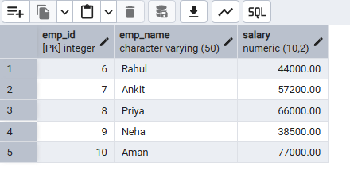

Step 6: Combining LOOP with IF Condition
DO $$
DECLARE
emp RECORD;
BEGIN
FOR emp IN SELECT emp_name, salary FROM employee LOOP
IF emp.salary > 50000 THEN
RAISE NOTICE '% is a High Earner', emp.emp_name;
ELSE
RAISE NOTICE '% is a Regular Employee', emp.emp_name;
END IF;
END LOOP;
END $$;
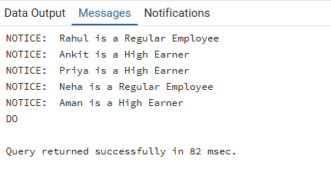

6. I/O Analysis (Input / Output)
Input:
• Employee or sample records inserted into a database table for iterative processing
• PL/pgSQL DO block containing procedural logic
• FOR loop constructs for fixed-range and query-based iteration
• WHILE loop with condition-based execution
• LOOP construct with explicit EXIT WHEN condition
• IF–ELSE conditions used inside loops for decision making
• UPDATE statements executed repeatedly within loop structures

Output:
• Repeated execution of SQL statements based on loop conditions
• Row-by-row processing of table records using FOR loops
• Conditional messages displayed during each iteration
• Successful salary updates or value modifications through iterative logic
• Proper termination of loops based on defined conditions
• Correct execution of procedural SQL demonstrating iteration control

Screenshots of execution and obtained results are attached.

7. Learning Outcomes
• Understood the need for iterative control structures in database programming
• Learned the usage of FOR, WHILE, and LOOP constructs in PostgreSQL
• Gained knowledge of executing repeated logic using PL/pgSQL
• Understood row-by-row processing and conditional execution in databases
• Developed foundational skills for writing procedural SQL in real-world applications

